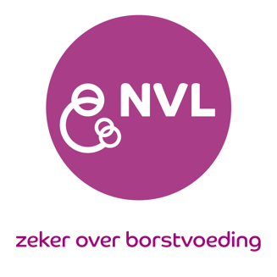
Formulier ‘Buitengewone omstandigheden’
Form ‘Extraordinary circumstances’

Gegevens / Your data
Name (meisjesnaam) :
Last name (partner) :
First names :
Date of Birth :
Street :
Postal code :
Place :
Country :
IBCLC number :
NVL number :
Aanvraag uitstel examen / Request deferral exam
- (From 2020 to) 2021 to 2022 without CERPs
- From 2021 to 2022 without CERPs
- (From 2020 to) 2021 to 2022 with 15 L-CERPs
- From 2021 to 2022 with 15 L-CERPs
Reden uitstel / Reason deferral
- I was not allowed to work, based on lockdown rules from the Dutch Ministry of Health.
- I could not work/study due to the effects of COVID-19 such as infections and mental health issues.
- I could not work/study due to private circumstances related to COVID-19 (illness, family-death(s), job loss or bankruptcy).

I hereby declare that I have completed this form truthfully.
Date: …………………………………………. Place: …………………………………………….
Signature:

This form is authorized by Nederlandse Vereniging van Lactatiekundigen.

Karin Tiktak, Chair
Voeg, indien je zelf COVID-19 hebt gehad, een verklaring van je huisarts daarover bij. Voor de overige bovengenoemde redenen hoef je geen doktersverklaring in te dienen.

